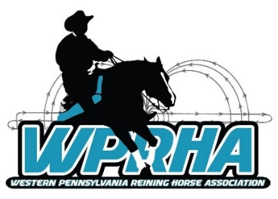
Meeting Agenda
Date: October 25, 2020
Location: Voodoo Brewery – The Compound, Meadville, PA
Time: 2:00 PM
Reason: Show Recap, Officer Nominations, General Information

Old News
- Updates are always posted on the Website and Facebook
- New Email to contact - admin@wprha.com
- All paid 2020 memberships will be extended through the year 2021. Any points earned from live shows (not virtual) in 2020 will roll over into the 2021 show season.
- All paid 2020 sponsorships will be extended through the year 2021.

New News
- August 15th Show at Penland
  - Total Entries: 21
  - Total Runs: 47
  - Paid Positions:
    - Show Secretary
    - Announcer
    - Judge
  - Overall Thoughts?
- Nominations

  - All Positions must be a PAID member for 2021 when taking office
  - Open Positions
    - Secretary
    - Treasurer
    - Board Members
  - Committees
    - Shows and Events
    - Social Media (Facebook and Website)
    - Green Reiner Program
    - Banquet and Awards
  - Nominations will be accepted online through 10/31.
    - www.wprha.com/vote
  - Voting will begin on 11/1 with a physical vote on 11/8 at the meeting
    - Not anonymous to track members (paid vs. non-paid)
    - Only paid members can vote
Next Meeting

  - November 8, 2020

General: 2:00-3:00 PM
Board: 3:00-4:00 PM

Silver Shores Restaurant
11934 Conneaut Lake Rd
Conneaut Lake, PA 16316

  - Get Thinking about:
    - Club Rules and Necessary Changes
      - Changes will be discussed and voted on at this meeting
      - Only paid members can vote
      - YRHA/TSRHA as a guide to follow
    - 2021 Show Season – Next Meeting
      - Winter/Spring Virtual Show Series?
      - Date or Venue Conflicts
      - Single Day or Weekend Show

